

PORTFOLIO ON RATING AND PARTICIPANT PREDICTIONS

*SSK 4604*

Lecturer’s Name: Dr Fadhlina binti Mohd Sharef

Prepared by: Ammar Rozman bin Mohd Azman

Matric Number: 197710

**Student’s Details:**



|  |  |
| --- | --- |
| Name | Ammar Rozman bin Mohd Azman |
| Matric Number | 197710 |
| Phone Number: | 010-9861415 |
| E-mail | [197710@student.upm.edu.my](mailto:197710@student.upm.edu.my) |

**Table of Contents**

1. **Introduction**
   1. **Problem Understanding………….. 4**
   2. **Importance of Stakeholders……... 5**
   3. **Hypothesis…………………………. 5**
2. **Description**
   1. **Attributes………………………….. 6**
   2. **Data Cleaning……………………... 7**
   3. **Visualizations……………………... 10**
   4. **Model Performances**
      1. **RapidMiner……………………. 17**
      2. **GoogleColab for Python…….... 25**
      3. **Comparison of GoogleColab and RapidMiner…………………… 26**
   5. **Streamlit…………………………… 27**
3. **Predictive Analytics…………………. 29**
4. **Conclusion………………………….... 35**
5. **Preferences…………………………... 36**
6. **Introduction**

The datasets given is CPD 2020 and Data Peserta CPD 2020. Both the datasets are given in the Excel by Microsoft. The first sheet, CPD 2020 is held ‘Latihan’, ‘Tarikh’, ‘Masa’, ‘Tempat’, ‘BilPeserta’ and ‘Purata Skor Penilaian Keseluruhan’. In simple words, the first sheet is for the average of each activities occurred in CPD programme. While, the second sheet Data Peserta CPD 2020 is held a deeper and more details of the events information. The attributes that are involve, ‘Klasifikasi’, ‘Nama Latihan’, ‘Tempat Latihan’, ‘Tarikh Mula’, ‘Tarikh Akhir’, ‘Masa Mula’, ‘Masa Akhir’, ‘Jumlah Jam’, ‘ID Staff’, ‘Jawatan’ and ‘Jabatan’ for each of the individual attend. In the picture below show both of the sheets that I mentioned above:

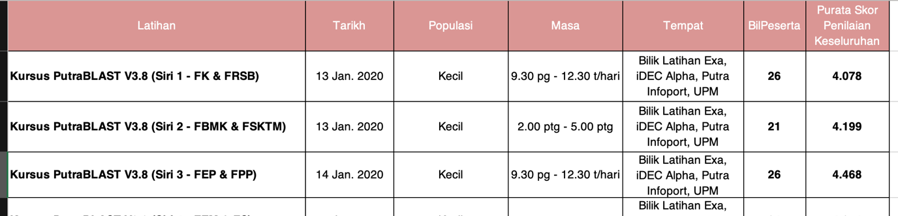

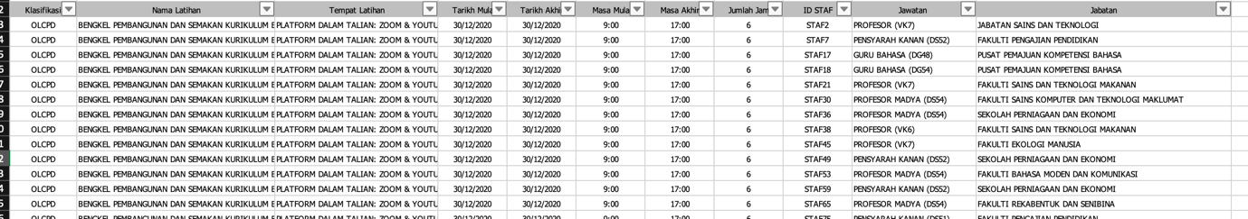

The visions of the project are we need to predict the ‘Skor Penilaian’ for each individu attends; how much the accuracy and classification error like we did before and how much people attends in each of the activities based on ‘Klasifikasi’. All the information and explanations will be explained below.

* 1. **Problem Understanding**

As in management team of course we want the best in every aspects especially in the effectiveness of the productivity. In 2020, we see that the scores were averagely in the Middle class which has below than 4.7 that we assume not achieve our target. So by doing this project we can simply examine which parts that we need to improvise in also can increase the number of participants that involve in our activities in CPD 2021 soon which only 5,437 numbers of participants in 2020.

* 1. **Importance of Stakeholders**

We clarified the stakeholders into two types which are Management and Participants.

**For Management:**

By having this streamlit, it will predict easily how many rates that will give for the next event and which activities need to be improved in order to get the performances better. Furthermore, it also helps to get more participants and help the university administrators to improvise the facilities in the faculties based on the events rating. It also helps the management to organize the events for example how many food should provide, how big the hall need and many more according to the rating.

**For Participants:**

After the management team improvised the system, the participants can easily involves what they need to be involved only in specific suitable for them.

* 1. **Hypothesis**

After aiming and create plans on the project works of course we need to list what is our thoughts and questions about the dataset; what we see and curious at the first place. So, to have the hypothesis we already listed a few questions in order to help us to show the path to complete this task. The questions are as below:

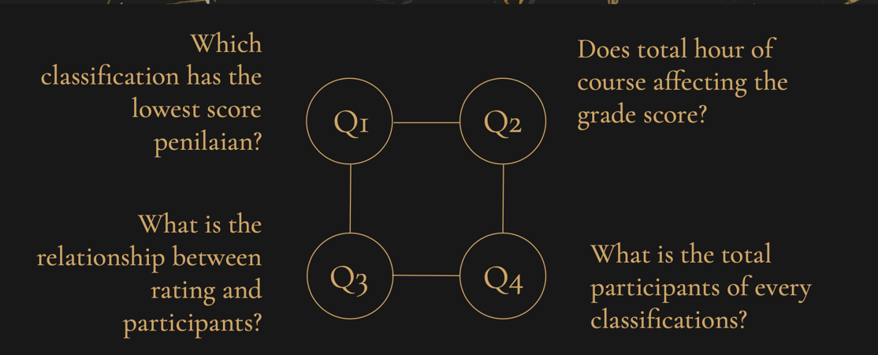

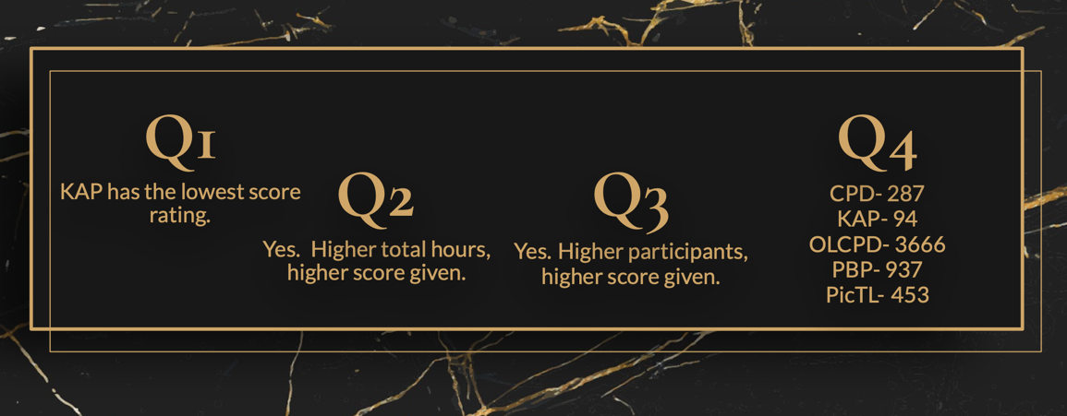

To answers of these questions are based on the visualizations that we already prepared in **2.3 Visualizations**.

1. **Description:**
   1. **Attributes**

There are several attributes in the first sheet (CPD 2020) and second sheet (Data Peserta CPD 2020) like be mentioned above. Anyway, not all of the attributes are been using in order to complete the Prediction Analaysis. For instance, ‘Jabatan’ is not too useful in order to answer how much people attends in each events. And there are also some data that missing or void that we need to do data cleaning. Even ‘Latihan’ attributes are different in the first sheet and second one, it is not problem for me to do the analysis since I used the ‘IF’ formula to compare the name of the activities. The activities name are readable and detactable. There are a lot of features that I used in order to read the data and ease the process for example ‘Filter’. By accessing Filter, I can directly see which data is missing and planning the datasets, what step will be taken to complete the project.

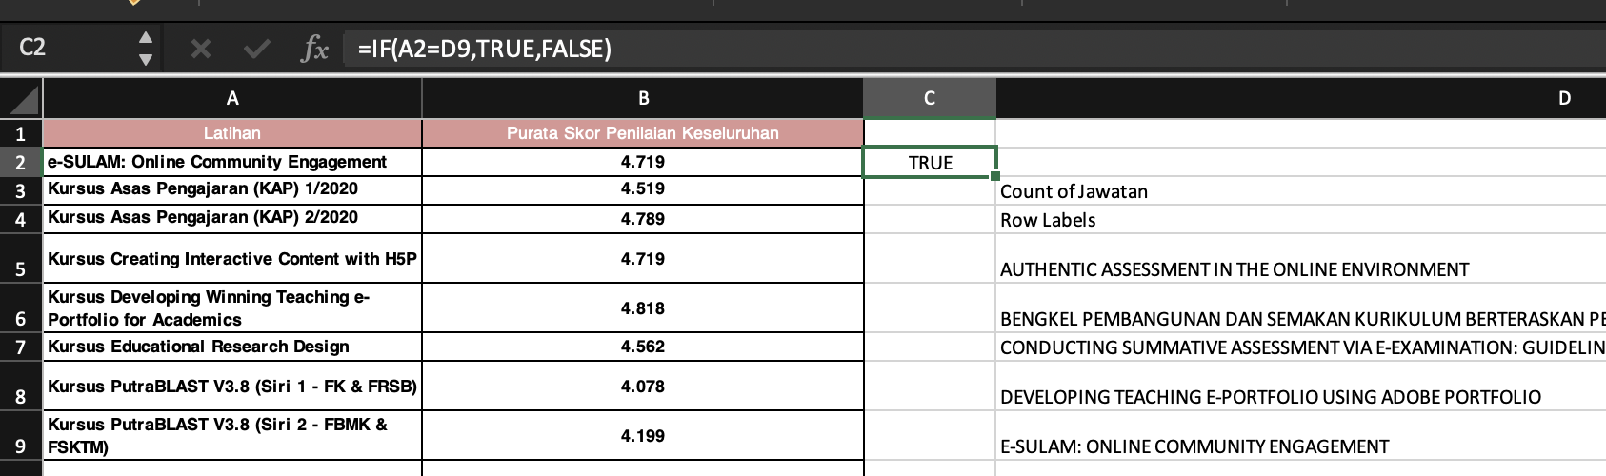

* 1. **Data Cleaning**

**2.2.1. Sorting Blanks**

By sorting the data using Filter, I saw a lot of data are missing.

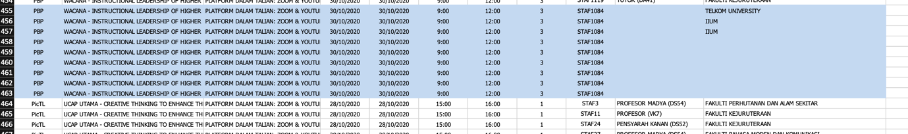

By doing the data cleaning, we can remove the void data. There are several steps that we can do:

1. Select the attributes that need to be cleaned.
2. Click on Data at the above section and enter filter.
3. Select the small box at the attributes and it will shows the data details.
4. Unclick all the data except for the blacks then click clear filter to delete all the void in the specific attributes.

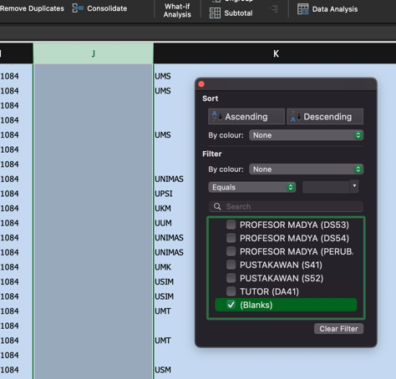

1. The process will be construct into each of the attributes in the Excel to ensure the process is smooth and valid.

**2.2.2 Using VLOOKUP**

There are some purpose that lead us to do the VLOOKUP formula. It is because we need to sort the ‘Latihan’ in the Sheet 2 into each ‘Purata Skor Penilaian Keseluruhan’ in the Sheet 1 that I already renamed as ‘CSkor’. It will automatically construct each of the ‘Tajuk Latihan’ with specific score that given and counted in average. Here the steps that I used to do the VLOOKUP:

1. Create an attribute in the dataset that we need to have new information.

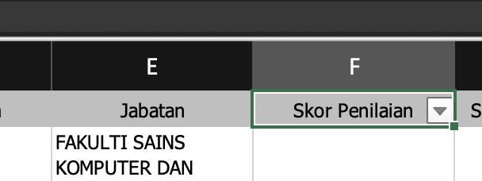

1. Then state the VLOOKUP formula at the Formula Bar above the attributes od the dataset.

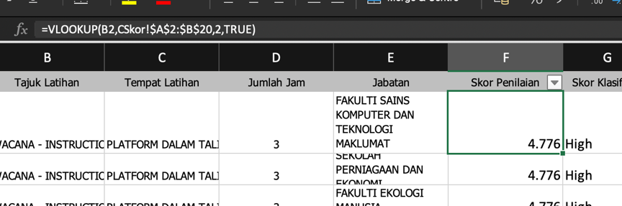

**Explanation of the VLOOKUP formula:**

=VLOOKUP(B2,CSkor!$A$2:$B$20,2,TRUE)

The purpose of VLOOKUP is to look up a value in a table by matching on the first column. The return value would be the matched value from a table. The syntax or explanation of the formula is:

=VLOOKUP(value,table,col_index,[range_lookup)

* **value**- The value to look for in the first column of a table.
* **table**- The table from which to retrieve a value.
* **col_index**- The column in the table from which to retrieved a value.
* **range_lookup**- [optional] TRUE= approximate match (default). FALSE= exact match.

*I used the ‘$’ (the dollar symbol) to lock the col_index of the formula to ensure the process will not miss around or failure occurring.

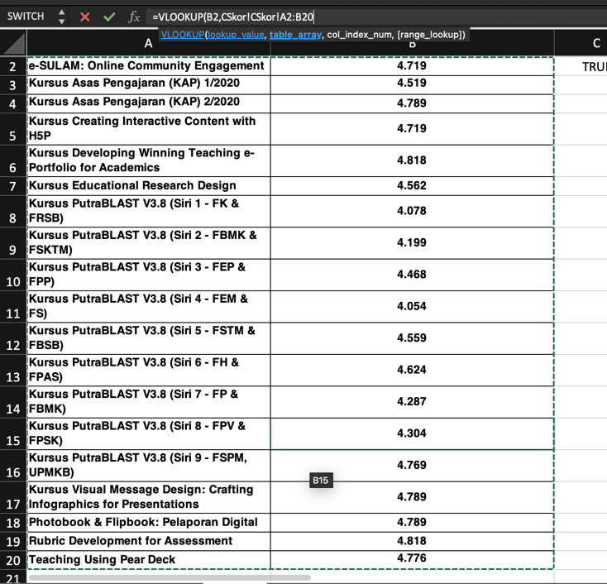

By successfully done with the formula, it will shows the entire ‘Skor Penilaian’ of each the events in the dataset we want to occur.

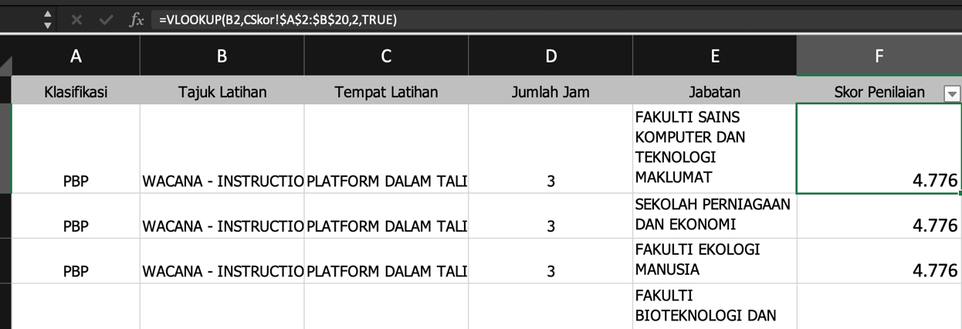

Not just that, I also that initiative to create an another attributes the classify the score of the events into three classes which are Low, Middle and High. The class is called ‘Skor Klasifikasi’. The attributes will help us in the **Model Performances** later on.

The range of the Skor Klasifikasi is:

|  |  |
| --- | --- |
| Skor Klasifikasi | Range |
| Low | Less than 4.782 |
| Middle | 4.782 – 4.802 |
| High | More than 4.802 |

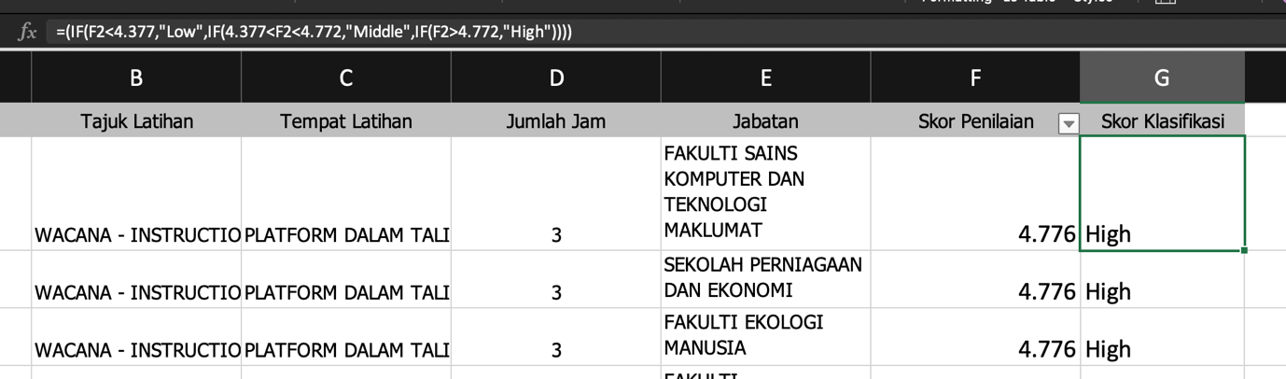

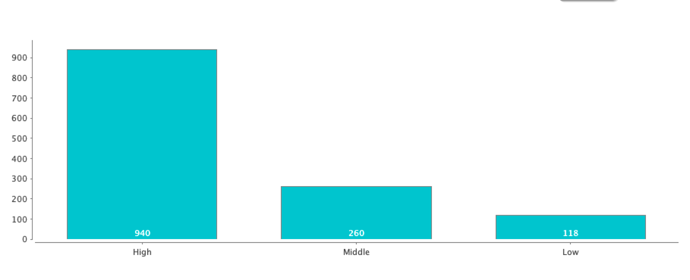

From the graphs above we can see that, most participants gave High score for each activities that they were attended.

* 1. **Visualizations**

For the visualization, we reach out two useful tools in order to complete the tasks given. Each of the visualizations will be arranged in title of the graphs and applications that we used to do the visualization which are PowerBI and Tableau respectively. The titles of the graphs below are based on the questions that we listed earlier to find out what are the factors or what is the score and amount of the participants depend on.

1. **Klasifikasi vs Skor Penilaian**

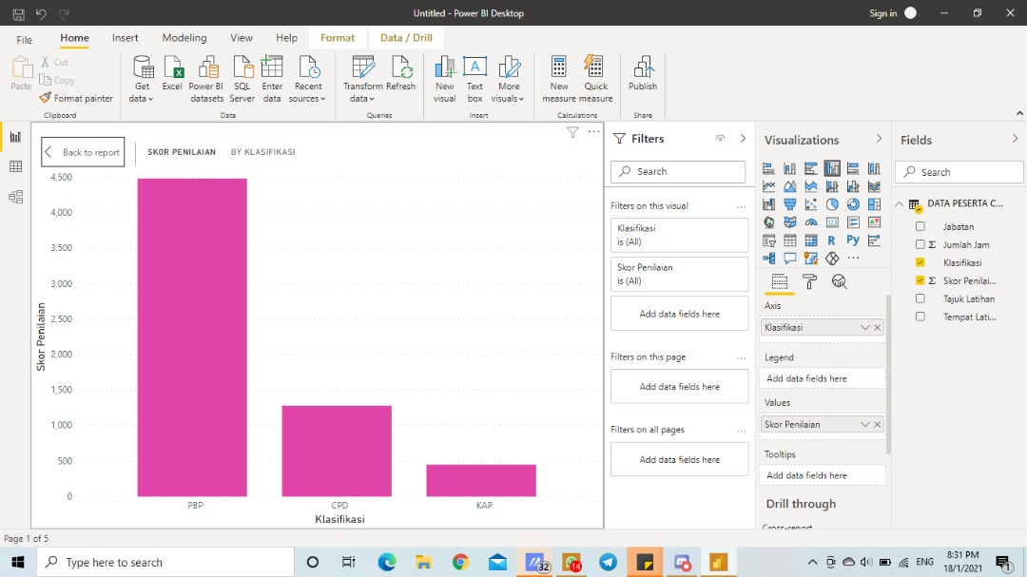

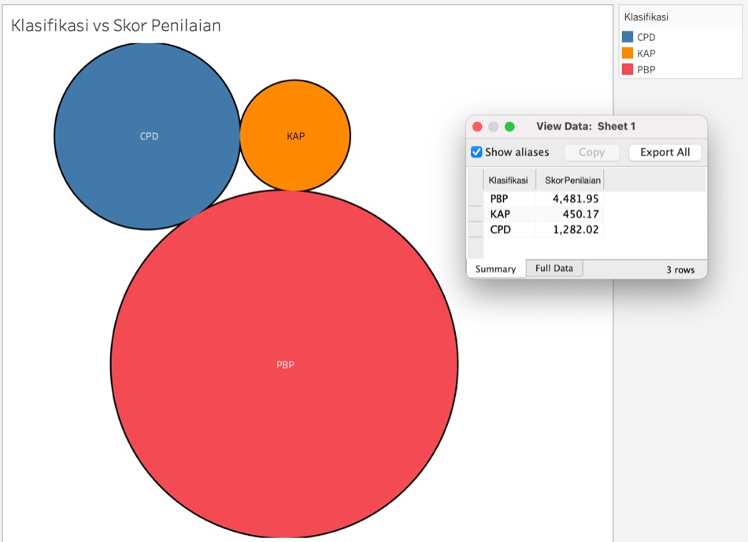

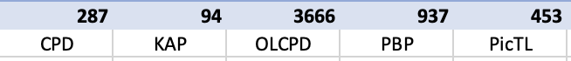

In the Classification and Score Rating graph, we can see that PBP has the highest score rating than the rest with 4,481.95 total scores followed by CPD and KAP.

1. **Tempat Latihan vs Jumlah Masa**

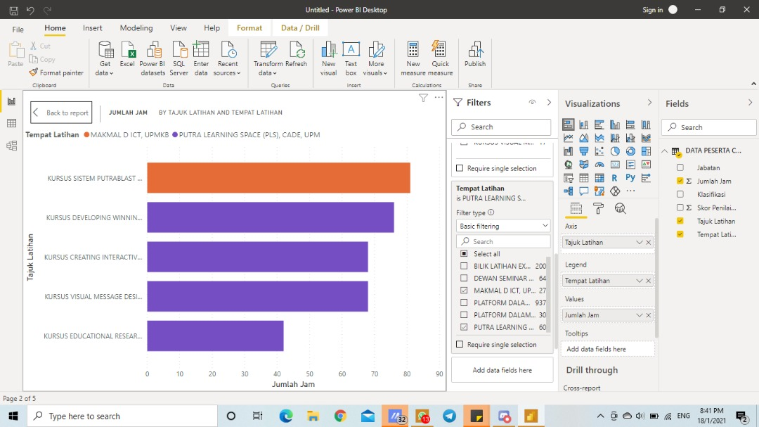

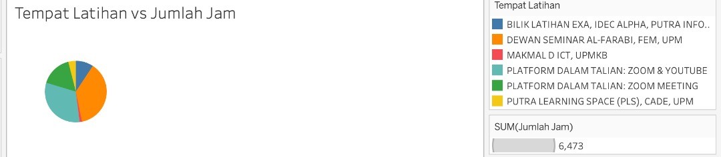

In the Activity Location and Total Hours graph, we can see that Kursus Sistem Putrablast that held in Dewan Seminar Al-Farabi, FEM, UPM is the most popular place to conduct CPD 2020 activities.

1. **Jabatan vs Skor Penilaian:**

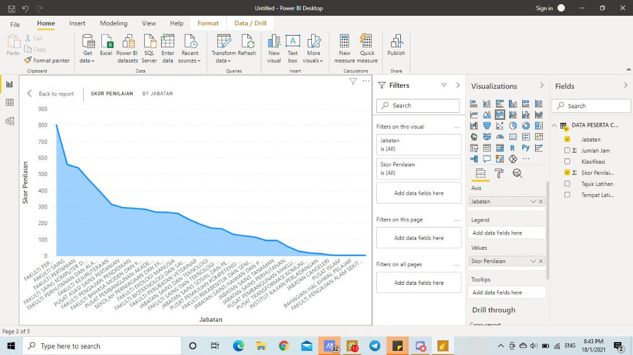

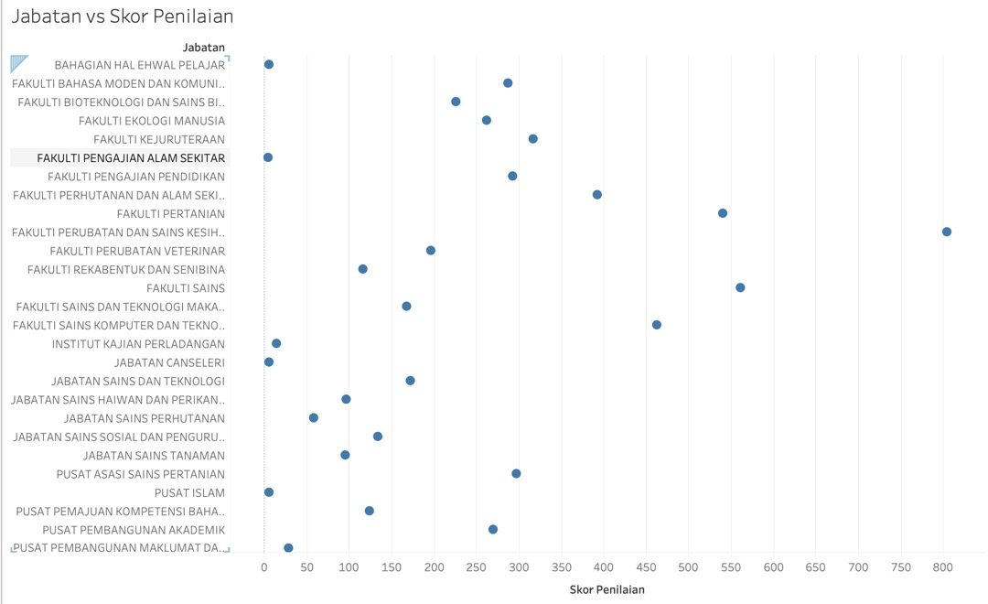

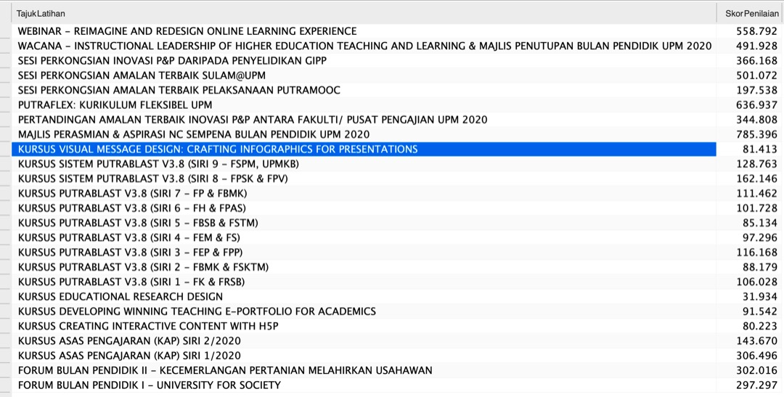

In the Department and Score Rating graph, we can see that Webinar – Reimangine and Redesign Online Learning Experience lead with far highest score than the rest with 558.792 scores.

1. **Jumlah Jam vs Skor Penilaian**

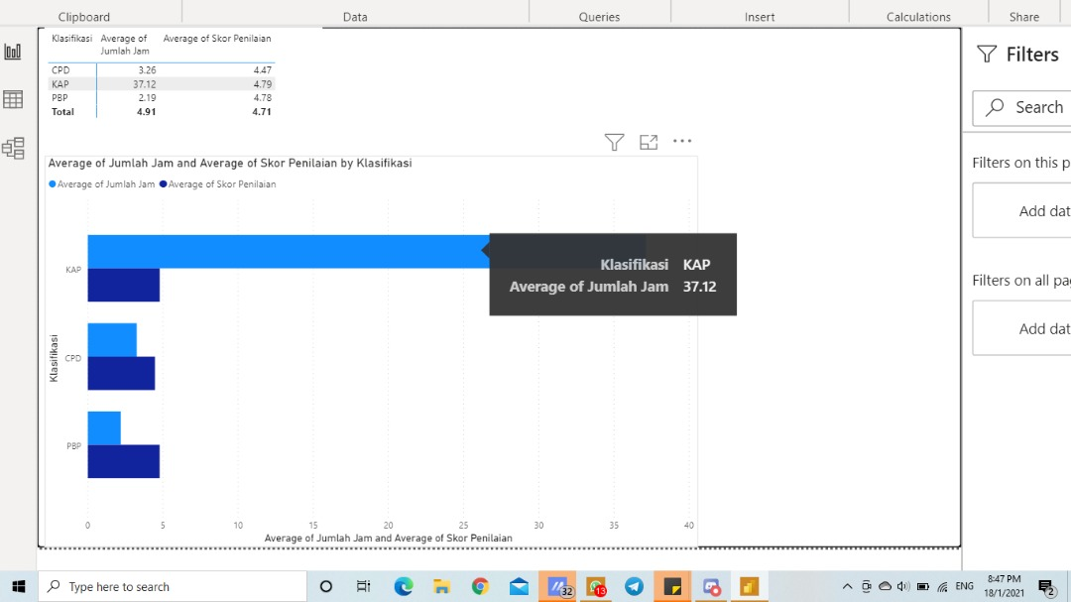

In the Total Hours and Score Rating, we can see that KAP has the highest score rating than the rest since it also be the most popular activity conducted in the year.

1. **Tajuk Latihan vs Skor Penilaian**

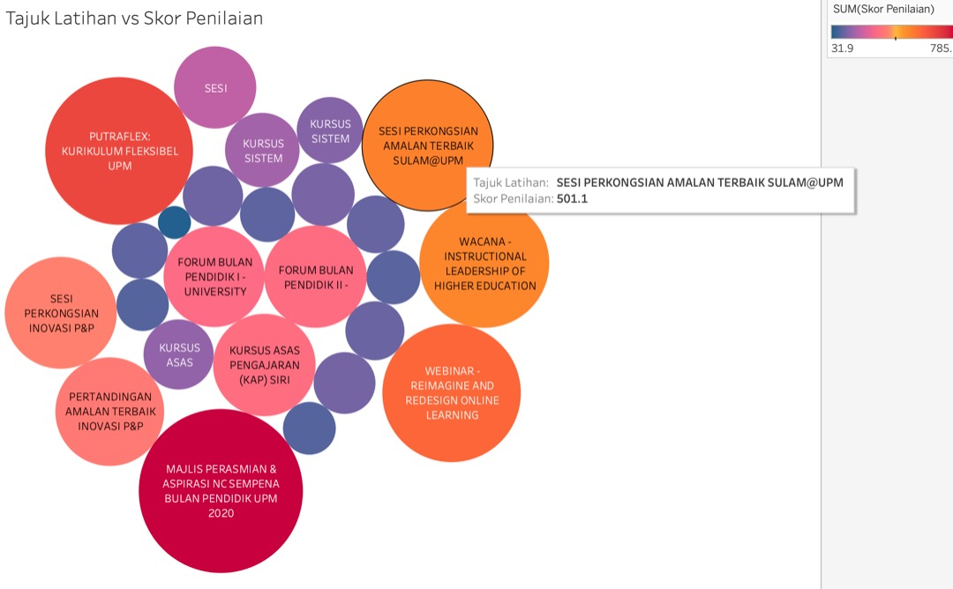

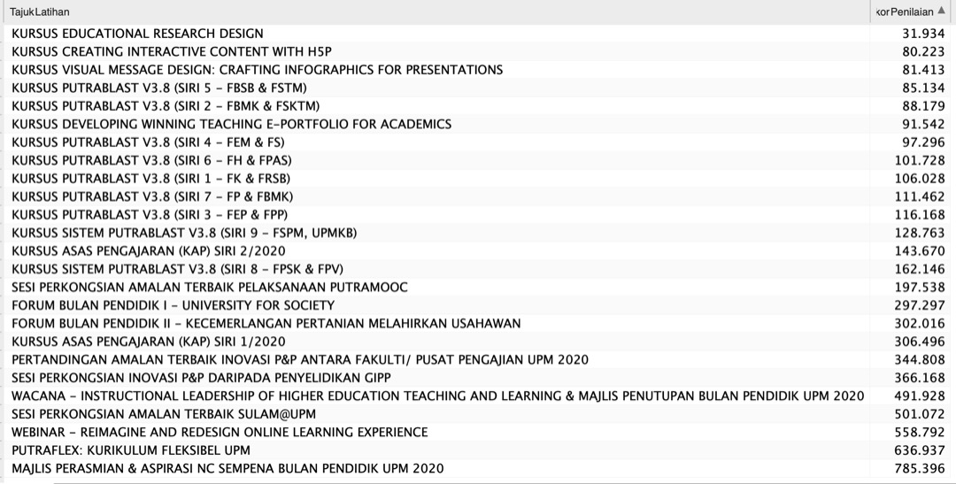

In the Activity Title and Score Rating graph, we can see that Majlis Perasmian & Aspirasi NC Sempana Bulan Pendidik UPM 2020 has highest score rating than other activities while Kursus Educational Research Design has the lowest score rating than the rest.

1. **Jumlah Jam bin Klasifikasi**

In the Total Hours and Classification graph, we can see that KAP got the higher marks than the rest with total hours of, 3489 hours. It shows that KAP events much popular held under the CPD 2020 events.

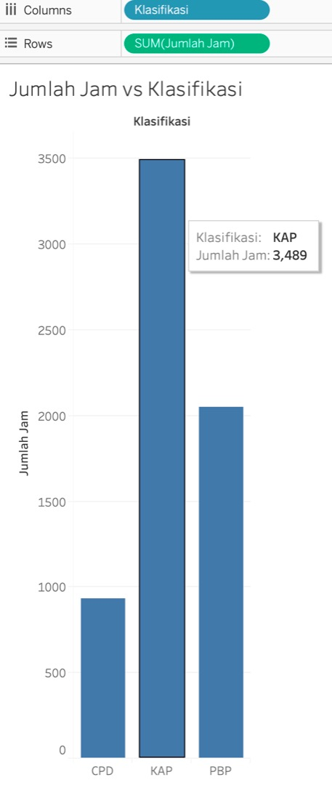

* 1. **Model Performances**

In the model performances, there is a very important to ensure the accuracy and the classification error of the prediction we do. There are many methods to measure them such as Decision Tree, Random Forest, Linear Regression and more. The path of the operators must be presented respectively follow how the data transmitted.

* + 1. **RapidMiner**

On RapidMiner, I implemented a new things that I never used before including in Business Analytic studies which is Discretize. I will explain the function of each parameters that I used in the RapidMiner in order to process my decision making.

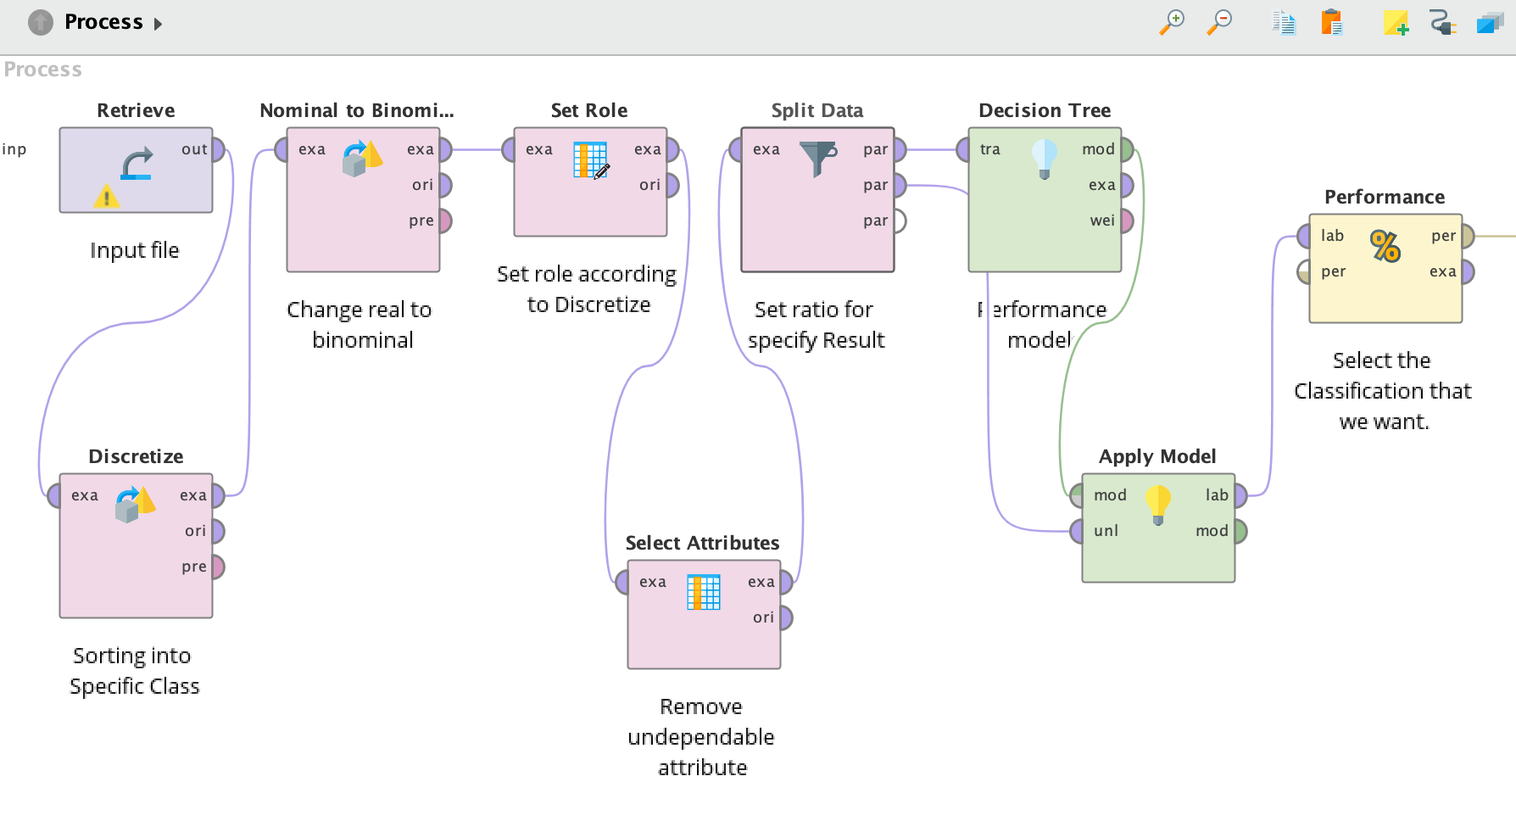

* **Retrieved**- Retrieved in RapidMiner is use to input the data folder into the process. It also can use Read parameter but it slower since it needs to process each time when you fill it. But, by using retrieved you just need once since you already saved the file in the repository in the application.
* **Discretize by Frequency**- Discretized by Frequency is for when you want the sort or separate the implement into each of class that you already classified in the Excel and edit the number of bins based on class you stated.

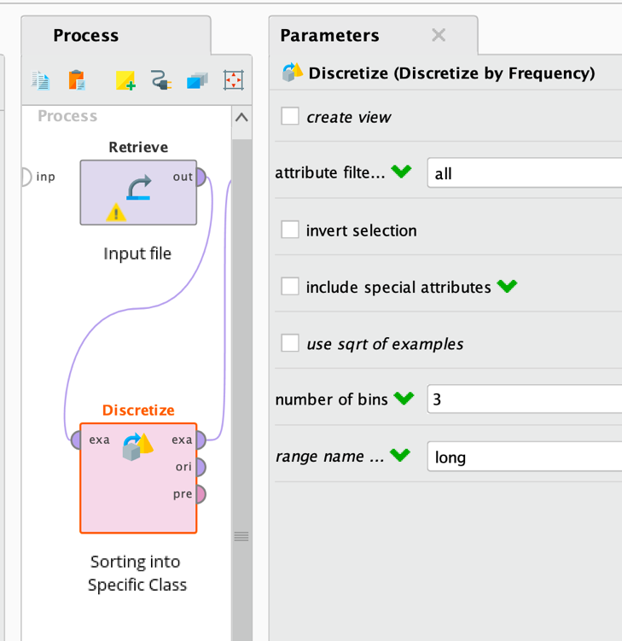

* **Nominal to Binominal**- Nominal to Binominal operator is used for changing the type of nominal attributes to a binominal type. This operator not only changes the type of selected attributes but it also maps all values of these attributes to binominal values i.e. true and false.
* **Set Role-** We using set role to determine the special attributes that we need to count.
* **Select Attributes-** Select attributes is using is mainly for separate the use and unuse attribute in order to calculate the attribute.
* **Split Data-** In split data, it will be boxes that we can fill to put ratio of our studies over 1.0. The top box usually 0.7 and below will be 0.3. But in some cases, people also put 0.8 and 0.2. The higher of top box the lower accuracy you can get formulally.
* **Decision Tree-** Decision tree is one of common models that people use to predict things in RapidMiner normally it uses to calculate the classification, the characterized data not numerical.
* **Apply Model-** In apple model, it for applied the parameters that we stated behind it. It also have goal to predict the unseen data and to transform data into a pre processing model.
* **Performance**- It will compatible the models and do generating.

In this turn, I am using Decision Tree and Random Forest to examine each of the Score Classification for each the activities held. By using Discretize by Frequency as suggested by. Dr Fadhlina, I need to apply it for every classification in the attribute which is Low, Middle, High. That is mean there will be each accuracy for the model performances.

1. **Decision Tree**

A decision tree is a graphical representation of all the possible solution to a decision based on certain conditions. We are using decision trees to extract main factors which influence the ultimate classification of a population into respective classes. Criterion parameter specifies the attributes which will be selected for splitting the tree. Gain index is one of its values that was utilized for the dataset.

The details and comparison I will explain at below after the Summarize table that I will construct after **Random Forest**. Path for the operators have been tagged on above in **page 14**.

The accuracy below is for **High**. The accuracy is 81.27%.

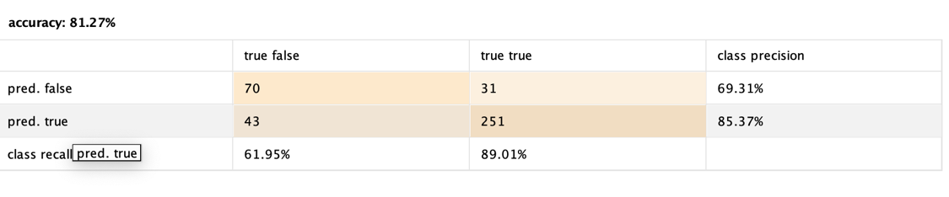

The classification error below is for **High**. The classification error is 18.73%.

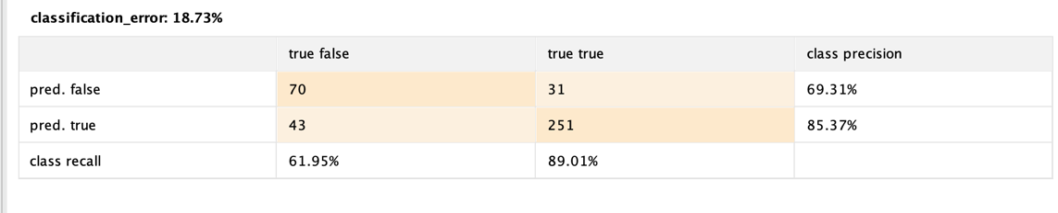

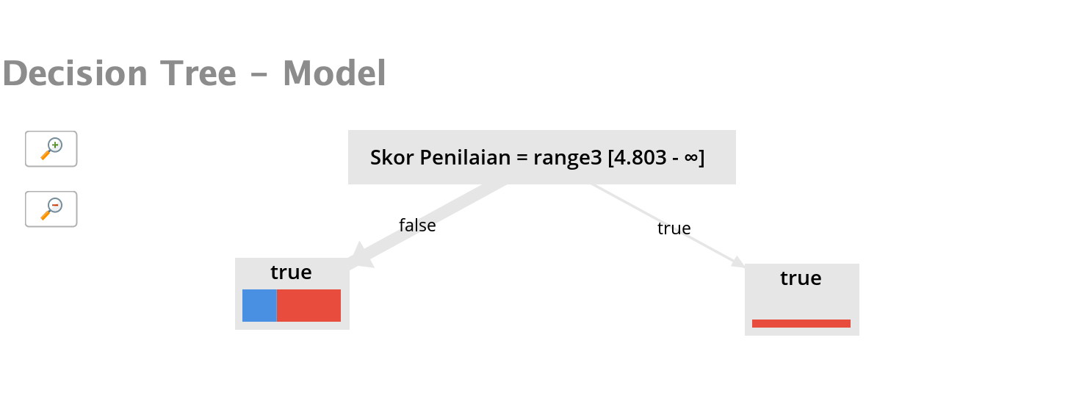

The accuracy below is for **Middle**. The accuracy is 83.04%.

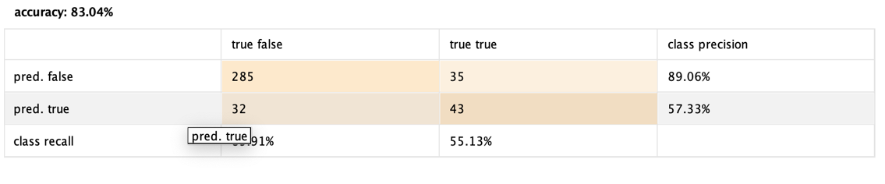

The classification error below is for **Middle**. The classification error is 16.96%.

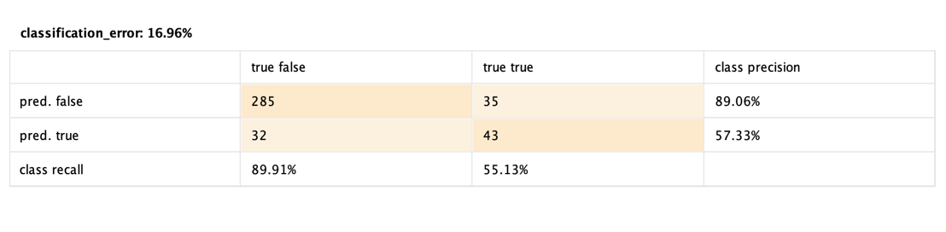

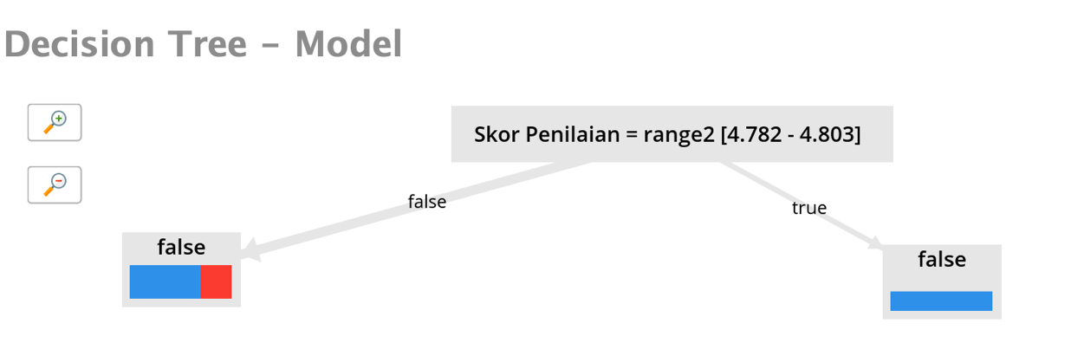

The accuracy below is for **Low**. The accuracy is 91.14%.

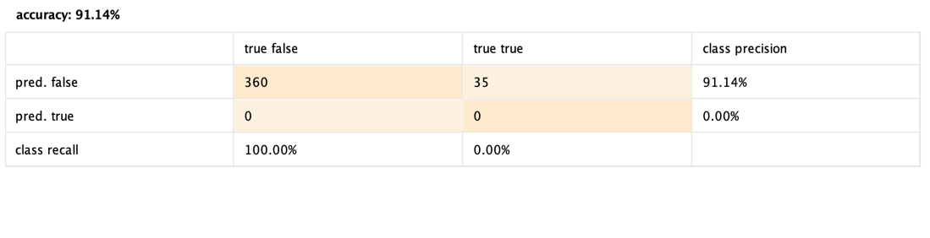

The classification error below is for **Low**. The classification error is 8.86%.

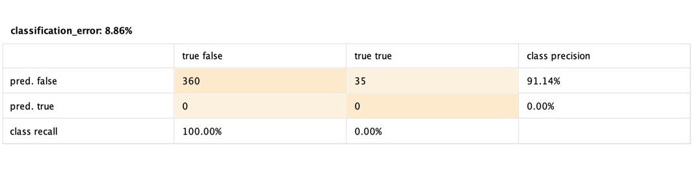

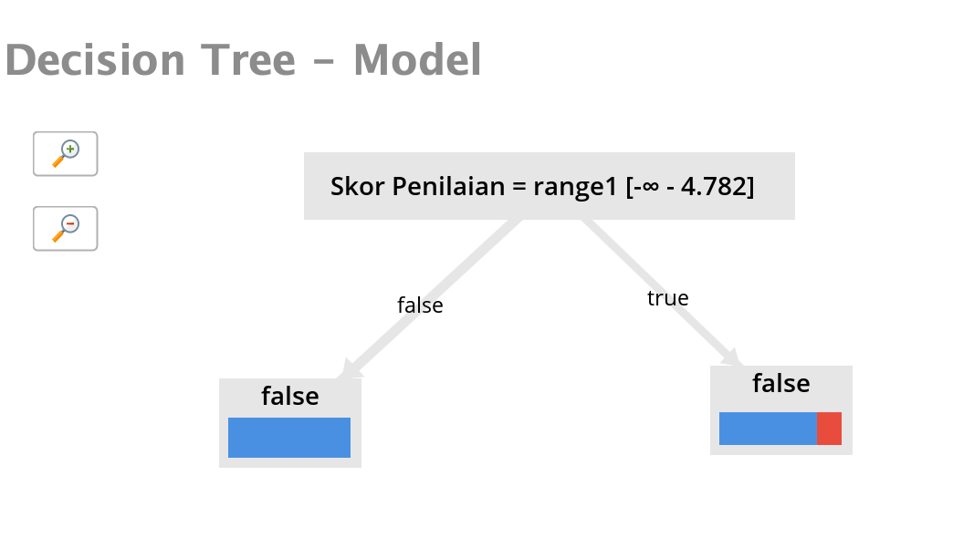

1. **Random Forest**

Random forests or random decision forests are an [ensemble learning](https://en.wikipedia.org/wiki/Ensemble_learning) method for [classification](https://en.wikipedia.org/wiki/Statistical_classification), [regression](https://en.wikipedia.org/wiki/Regression_analysis) and other tasks that operate by constructing a multitude of [decision trees](https://en.wikipedia.org/wiki/Decision_tree_learning) at training time and outputting the class that is the [mode](https://en.wikipedia.org/wiki/Mode_(statistics)) of the classes (classification) or mean/average prediction (regression) of the individual trees. Random decision forests correct for decision trees' habit of [overfitting](https://en.wikipedia.org/wiki/Overfitting) to their [training set](https://en.wikipedia.org/wiki/Test_set). Random forests generally outperform [decision trees](https://en.wikipedia.org/wiki/Decision_tree_learning), but their accuracy is lower than gradient boosted trees. However, data characteristics can affect their performance.

Path for Random Forest:

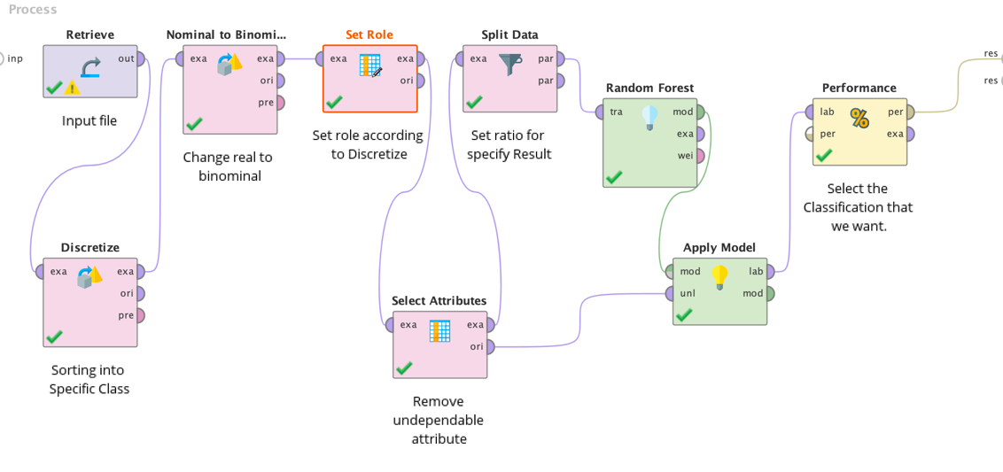

The description for each of the operators already be mentioned in **page 14**.

The accuracy below is for **High**. The accuracy is 83.31%.

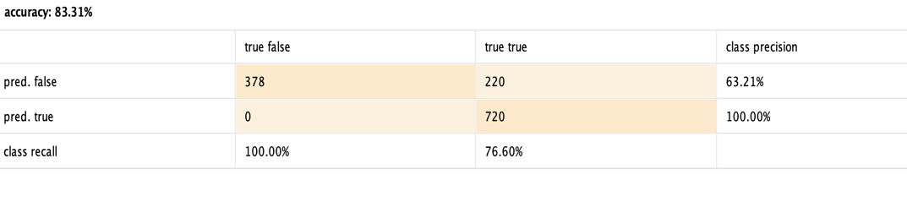

The classification error below is for **High**. The classification error is 16.69%.

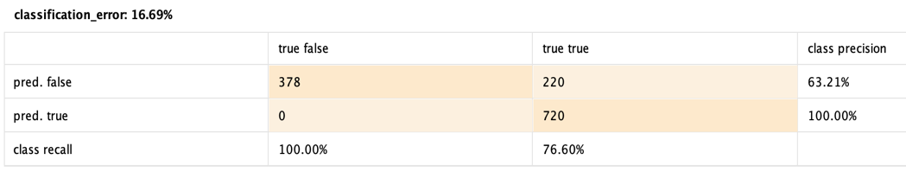

The accuracy below is for **Middle**. The accuracy is 82.85%.

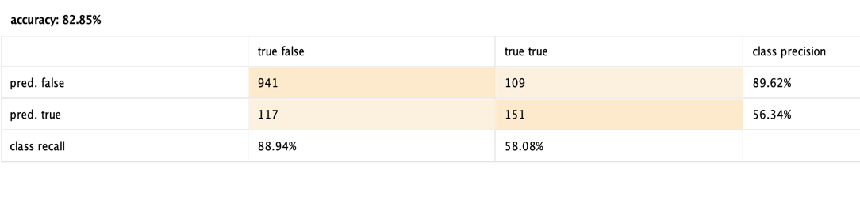

The classification error below is for **Middle**. The classification error is 17.15%.

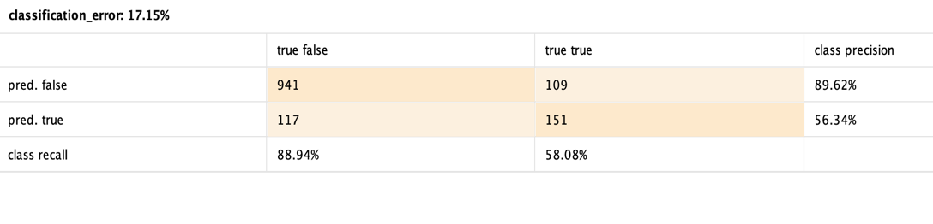

The accuracy below is for **Low**. The accuracy is 91.05%.

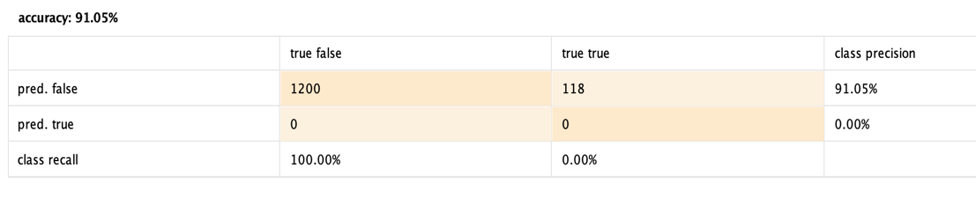

The classification error below is for **Low**. The classification error is 8.86%.

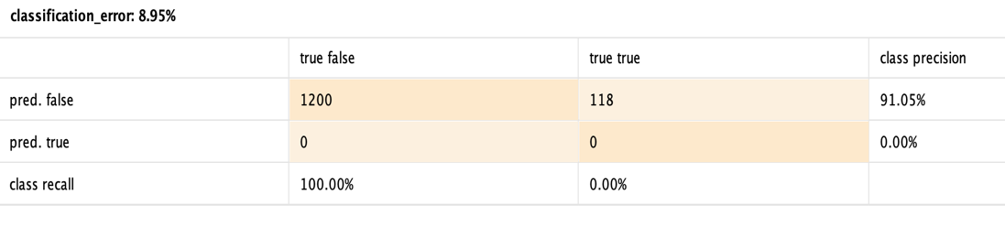

**2.4.1.1 Comparison Table in RapidMiner**

|  |  |  |  |  |
| --- | --- | --- | --- | --- |
| **70:30** | **Decision Tree (%)** |  | **Random Forest (%)** |  |
|  | **Accuracy** | **Classification Error** | **Accuracy** | **Classification Error** |
| **Low** | 91.14 | 8.86 | 91.05 | 8.95 |
| **Middle** | 83.04 | 16.96 | 82.85 | 17.15 |
| **High** | 81.27 | 18.73 | 83.31 | 16.69 |
| **Average** | **85.15** | 14.85 | **85.74** | 14.26 |

|  |  |  |  |  |
| --- | --- | --- | --- | --- |
| **50:50** | **Decision Tree (%)** |  | **Random Forest (%)** |  |
|  | **Accuracy** | **Classification Error** | **Accuracy** | **Classification Error** |
| **Low** | 91.05 | 8.95 | 91.05 | 8.95 |
| **Middle** | 82.09 | 17.91 | 82.09 | 17.91 |
| **High** | 83.31 | 16.69 | 83.31 | 16.69 |
| **Average** | **85.43** | 14.51 | **85.43** | 14.51 |

Based on above we can see that Random Forest achieved higher Average Accuracy and low Classification Error than Decision Tree. Nevertheless, the differences are very small and the each of the accuracy of the classes are close. The difference of average result for Accuracy is less than 1 which is (85.74-85.15), 0.59 only.

**2.4.1.2 Assumption and Conclusion**

After doing the table, I also explore the RapidMiner in the AutoModel to see deeper about the results that I achieved.

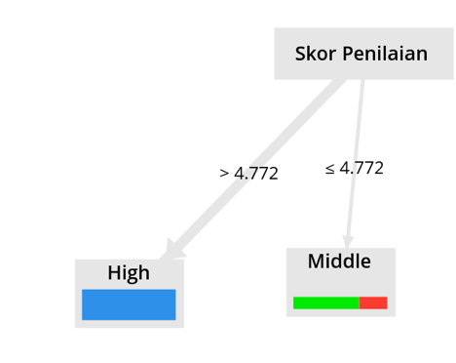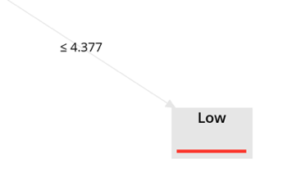

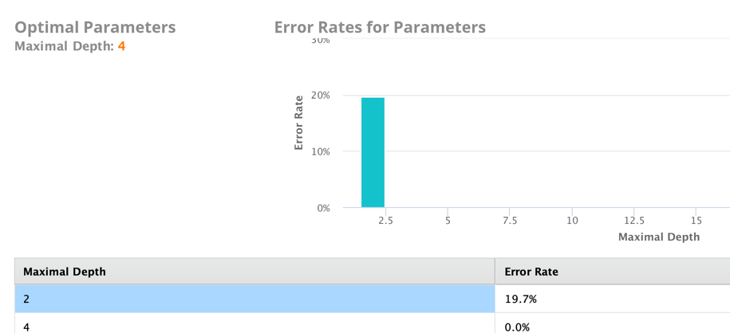

The error rate only occurred at maximal depth, 2 with 19.7%

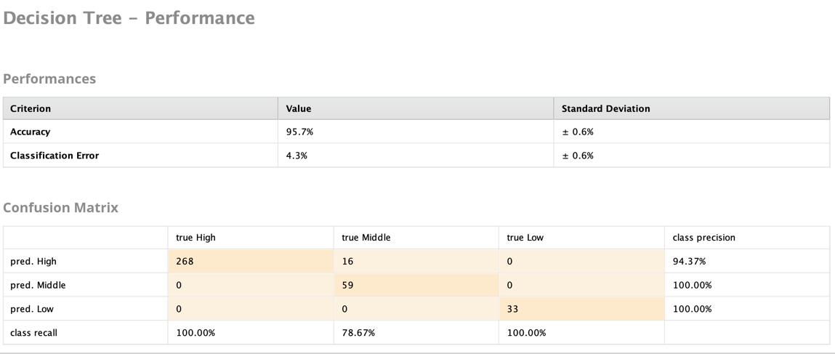

Overall of Skor Klasifikasi we can see that the accuracy is high with 95.7% and the only not 100% of true is at the Middle score of the events.

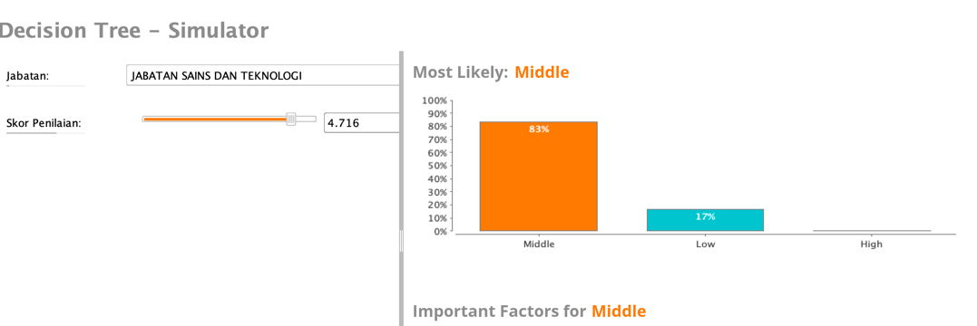

In the Simulator, we also can see what is actually specific score given for each Jabatan and we also can see how much the Jabatan attributes affect the Skor Penilaian.

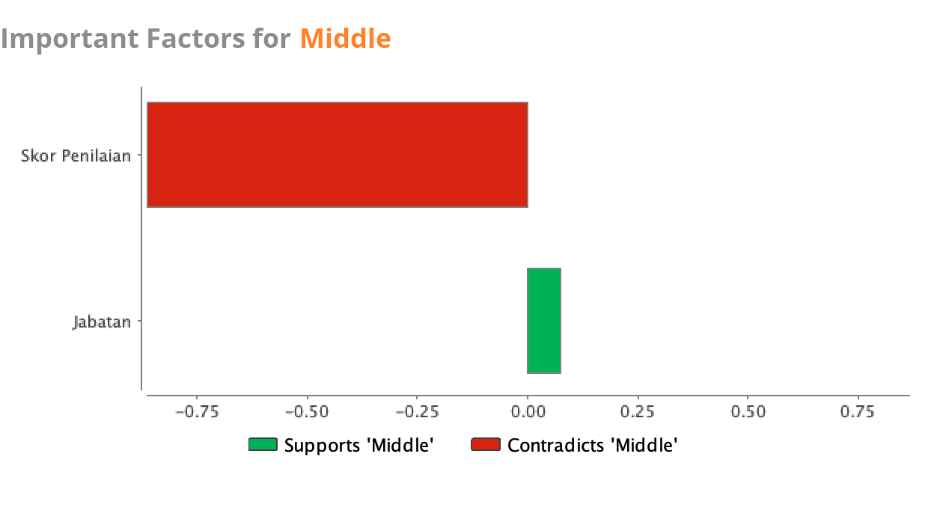

From the bar graph above, we can see that how much Jabatan supports the score given. In the assumption, the distance of the event places are one of the factor.

* + 1. **GoogleColab For Python**

On GoogleColab, we use it to do Python codes. The Python codes will be given through the link and it is important to see the before and after tunning. Here are some important lines of our codes:

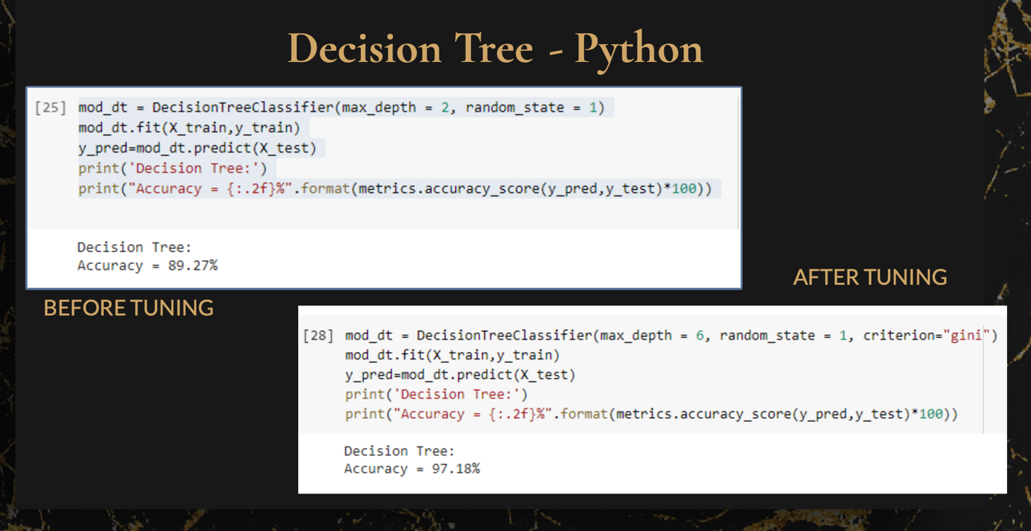

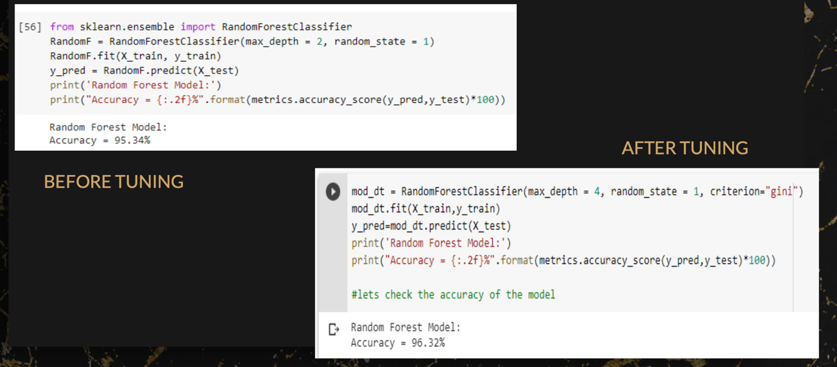

These are the performance models that we selected. First picture is decision tree and the second one is random forest.

|  |  |  |  |
| --- | --- | --- | --- |
|  | **Model** | **Decision Tree (%)** | **Random Forest (%)** |
| 70 : 30 | Before Tuning | 82.56 | 82.56 |
| After Tuning | 97.18 | 94.80 |
| 50 : 50 | Before Tuning | 79.67 | 91.96 |
| After Tuning | 93.63 | 95.60 |

Based on the table above we can see that all models show increase in accuracy after tuning. The best model goes to70:30 after tunning in decision tree with 97.18% accuracy.

* 1. **Comparison of GoogleColab and RapidMiner**

For the comparison I will differentiate based on the ratio. The accuracy of decision tree is 85.15% while the random forest is 85.74%. The accuracy calculated in python almost has difference of 12% that is 97.18% while random forest the difference is 9%. Next the data is split into 50:50 ratio where size test and train are calculated to be same. Based on the current split the accuracy scores of all classes is the same for. Decision Tree and Random Forest in the RapidMiner. There only have different in Python where 93.63% and 95.60% after tunning.

* 1. **Streamlit**

In Streamlit, I do matched the Pyhton codes and some of the variables for the streamlit. For streamlit, I used PyCharm to do the codes and show the visulizations. After run the codes, it will give a link to access the streamlit.

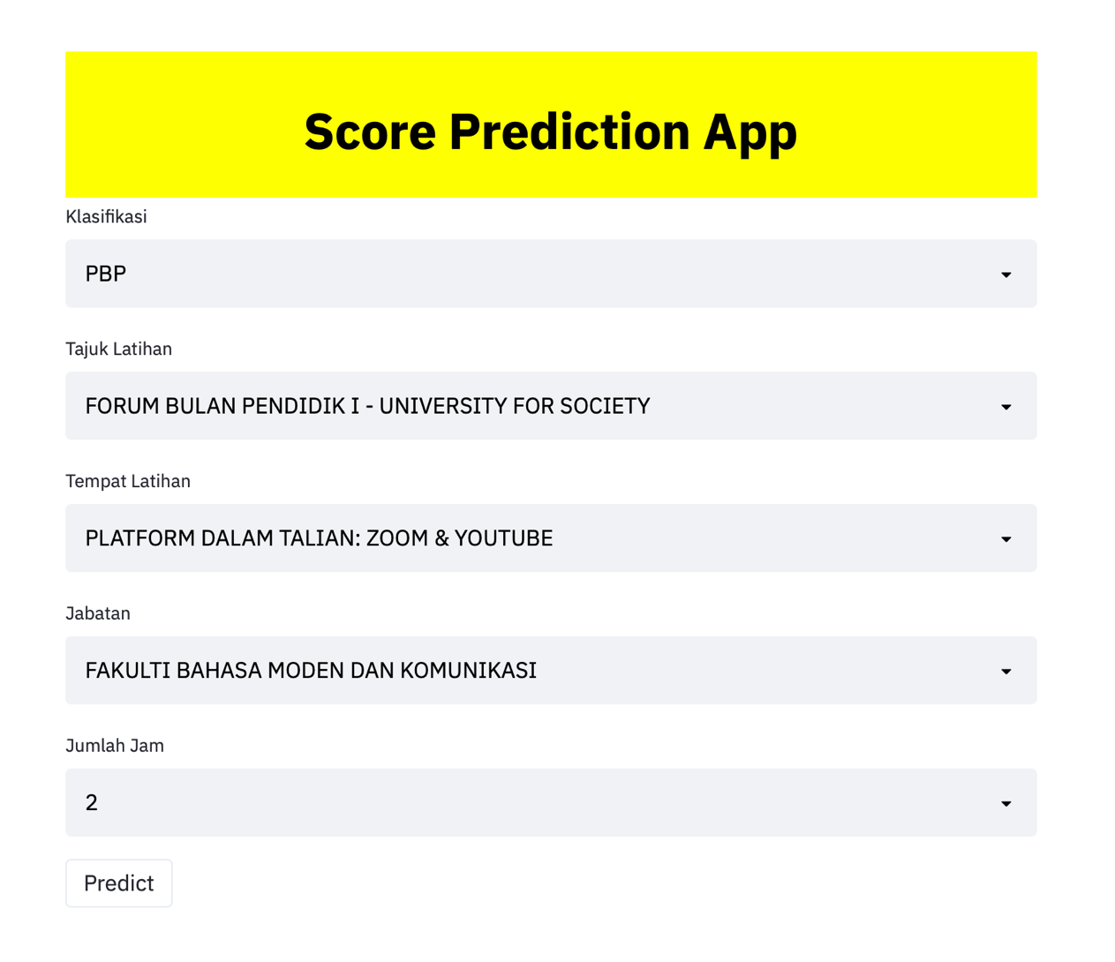

Picture above shows the output of the web. The user can select the ‘Klasifikasi’, ‘Tajuk Latihan’, ‘Tempat Latihan’, ‘Jabatan’ and ‘Jumlah Jam’. But selecting all this, the user can predict how much the score will given through the selected data.

In the beginning of the project, I plan predict the score but in machine learning, we only can predict integer which will convert all the score into 5 since the scores given were higher than 4.5.

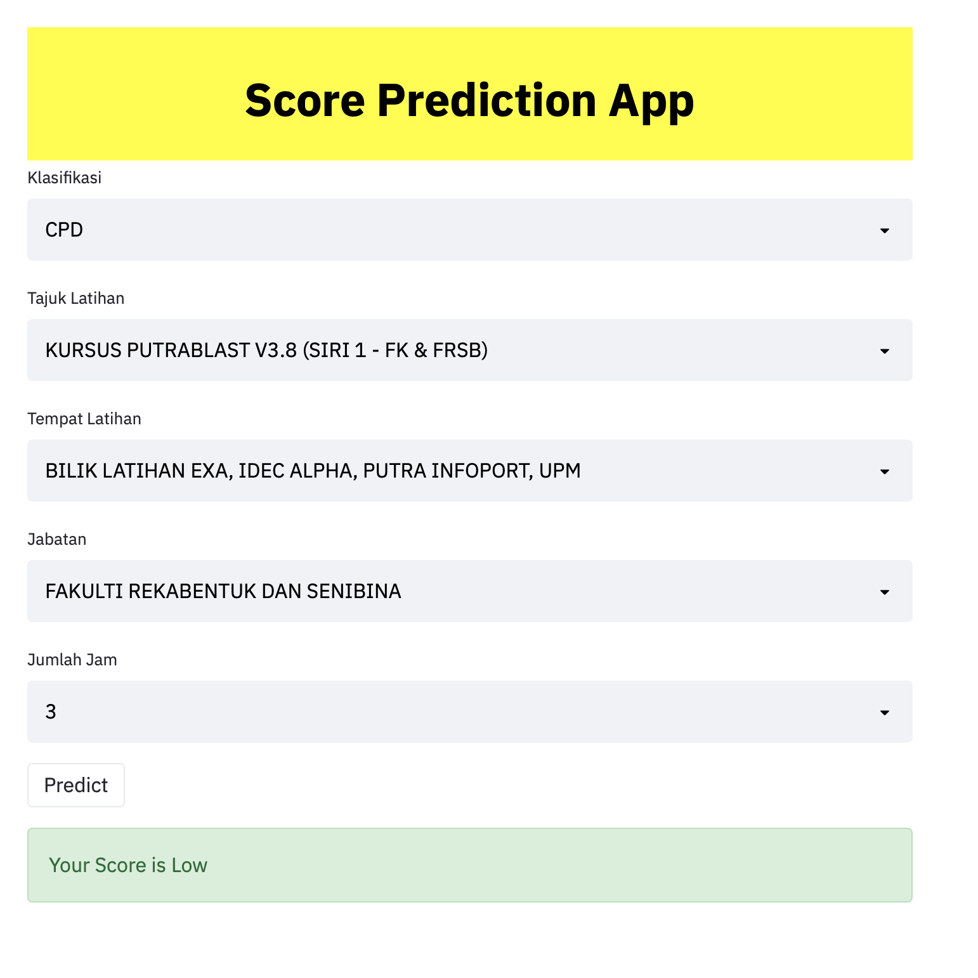

As in the Excel I do selected the data based on the dataset. The score shows Low in average.

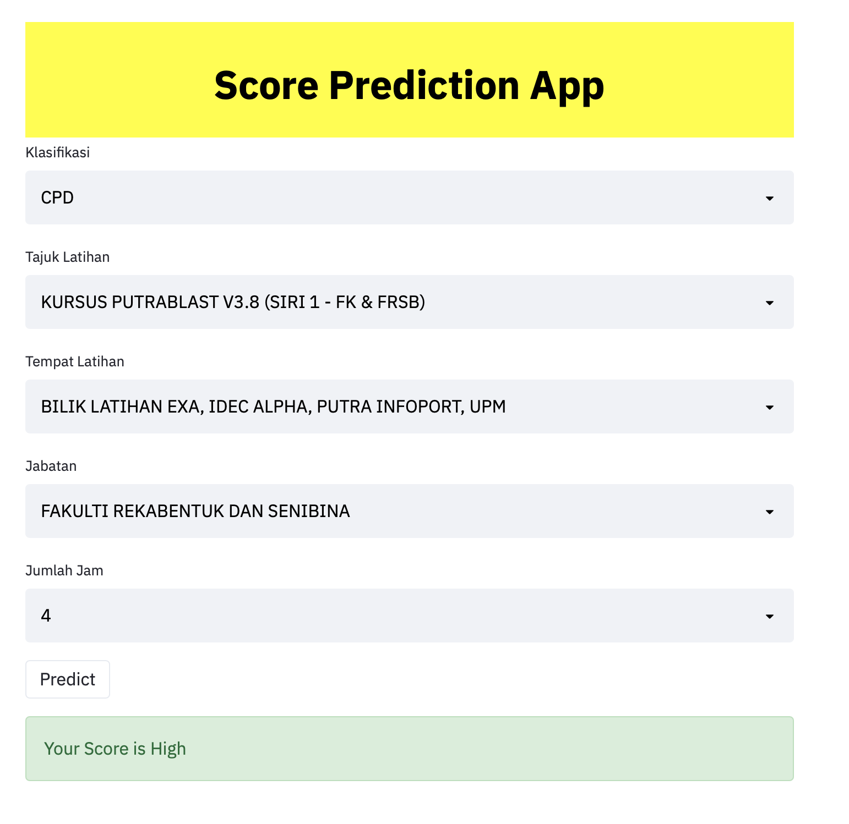

But once I changed the total hours, the score change into High. The hypothesis is the participants love Kursus Putrablast V3.8 (Siri 1-FK & FRSB) more. The total hours 3 is not enough the output is low. So that the participants want more and dive deeper about the activity.

1. **Descriptive Analytics**

The interesting part is, in this project we implement a new thing of the studies, Descriptive Analytics. Generally, Basically, Descriptive analytic is using in the Data Cleaning in order to fill the void and null into values. In the original sheets that given, there are no ‘Jumlah Peserta’ attribute to count the number of persons attend each of the activities held in the CDP 2020 Planning.

To construct the Pivot table, we need a formula to count and arrange it into a new sheet. For example we want to predict the number of persons attend each of the activities. At the below, I already prepared an instruction.

1. To do that, we must select the entire rows of ‘Jawatan’ and ‘Klasifikasi’ in the ‘Data Peserta CPD 2020’ and click Pivot table at Insert section.

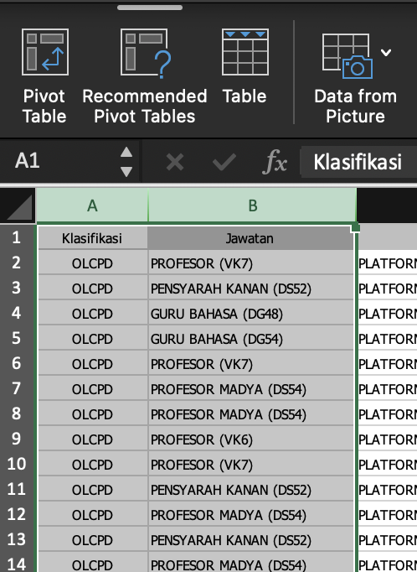

1. In the box appeared, do click OK button if you agreed to the table selected and keep the Pivot table at the new worksheet.

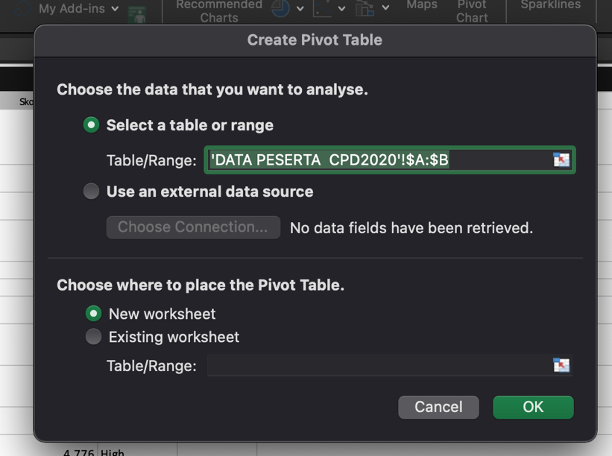

1. Construct the PivotTable into filters, rows, columns and values to Count or else you can construct how you like and easy to read.

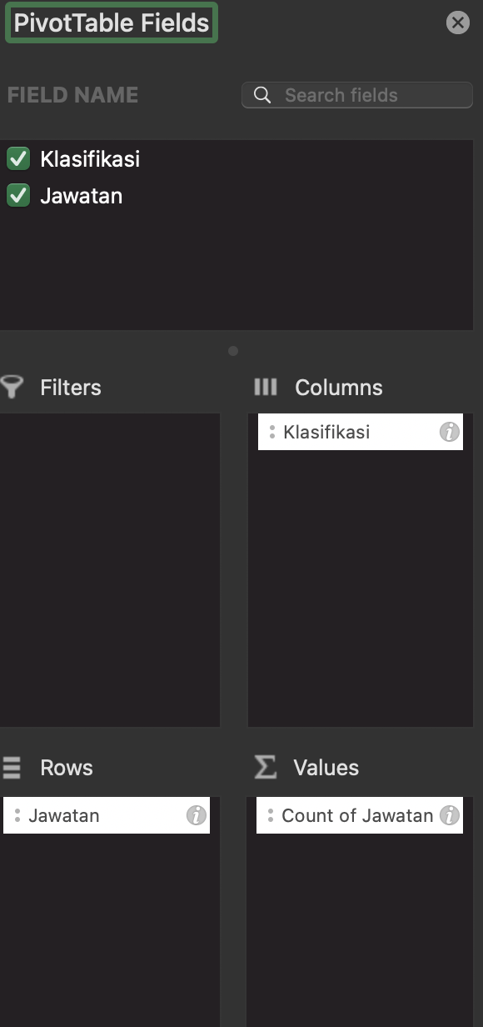

1. The table constructed automatically based on the above commands.

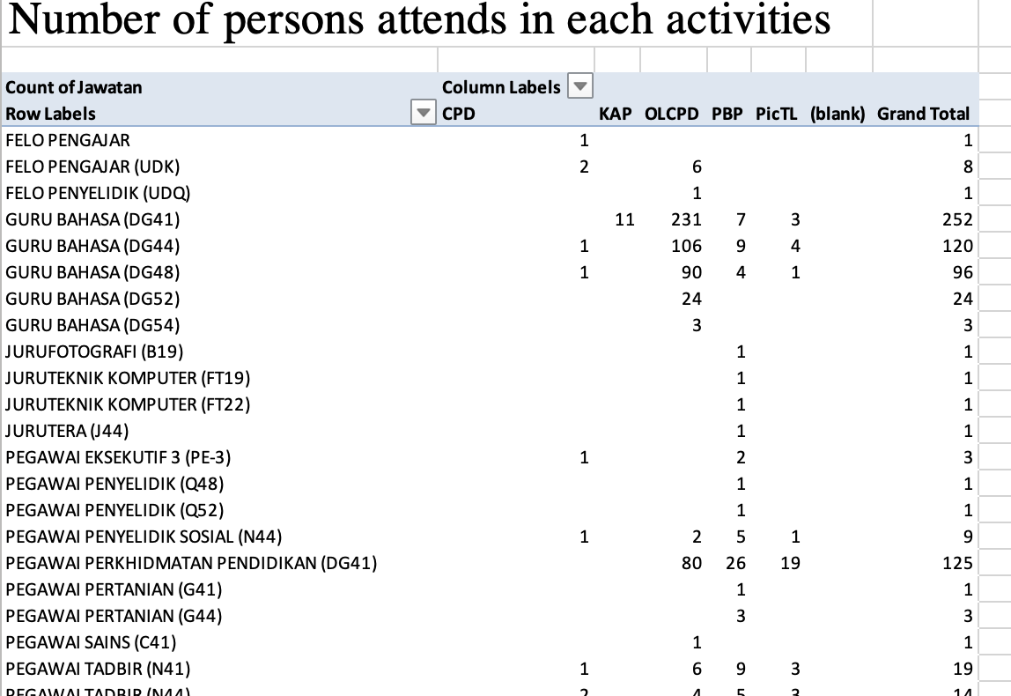

Lastly, you can get the amount of persons attend in each activities held in the project base on each activities and total of all the activities involved.

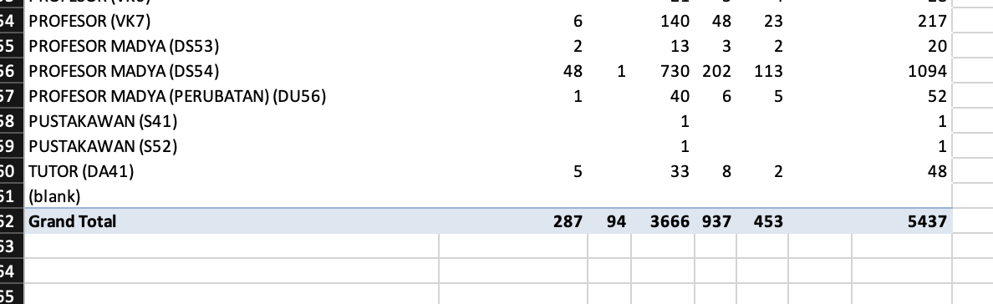

* 1. **Clustering in RapidMiner**

For descriptive analytics, it has its own model performance. I do clustering for that and to show the visualization I create an operator that name Cluster Model Visualize.

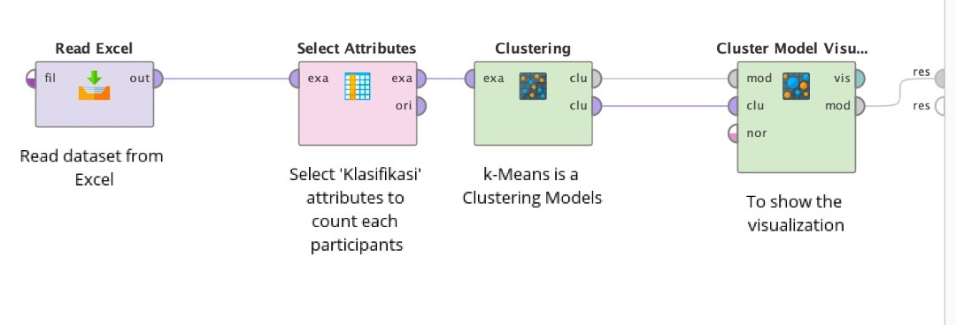

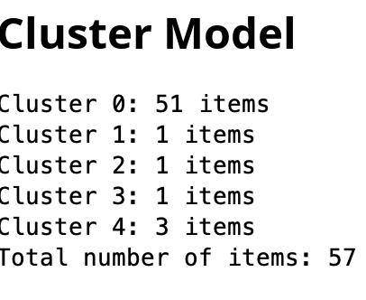

Cluster Model shows the numbers of item in each of the clusters it seems that cluster 0 has the highest number of clusters it will parallel with the cluster graph.

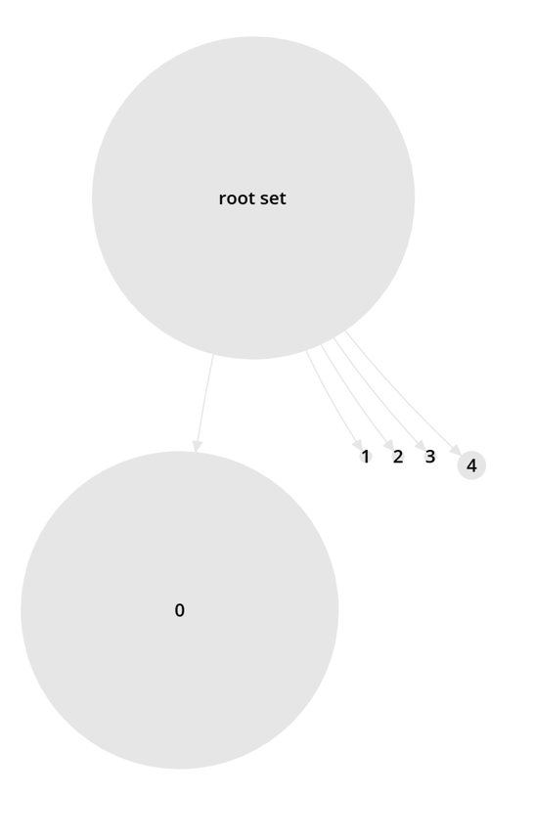

Cluster 0 received the higher numbers of items following by cluster 4 and the rest. It seems like cluster 0 contains the highest similar traits than the rest with much more difference.

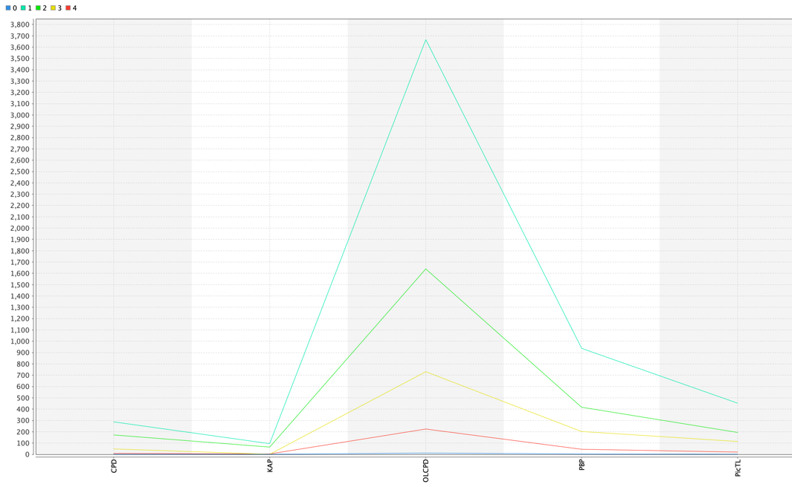

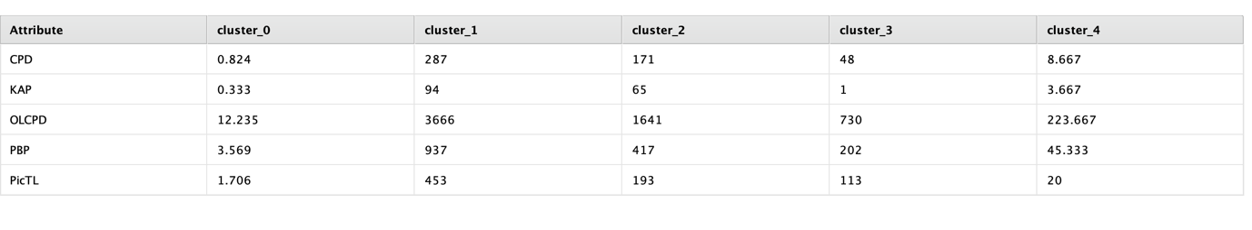

This above table shows Centroid table. OLCPD has the higher cluster with 223.667

* 1. **Clustering in GoogleColab**

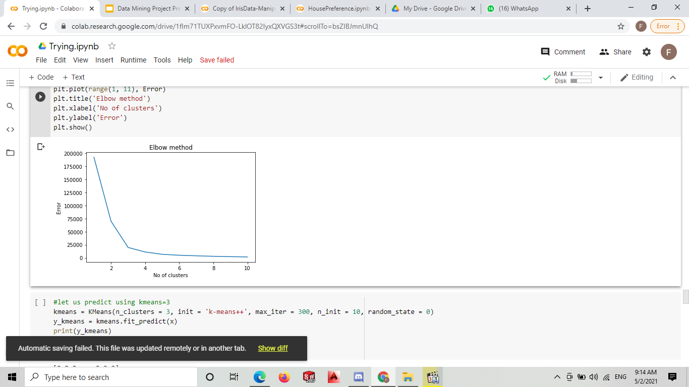

Above graph shows an Elbow method. By using the elbow method, we get the k=3 because the graph at that point is almost linear.

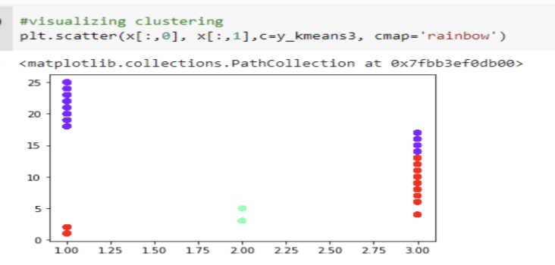

These three colours show the class Low, Middle and High.

1. **Conclusion**

In the conclusion, from this project there are flow that we need to follow. First is data cleaning, visualizations, performance models which contains two codes and visualization and streamlit. In these path we can see how much accuracy our prediction by controlling the ratio. Other than that, we also can analyse the data through the tables and graphs that we can get through the parameters in RapidMiner. For the visualizations, we do use PowerBI and Tableau to see the rough of the information in Excel after cleaning. Data cleaning is very important to ensure our data is our from null and missing data. Some of it will fill with average while some remain will be deleted. The interesting part is in RapidMiner. In the RapidMiner, we also can trace a specific graph that we want also see the what is being the factor of our. Accuracy in the Auto Model. Lastly in Python and streamlit, we do codes. Google Colab is actually same with RapidMiner, it finds accuracy but by coding while the streamlit is actually far more interesting. While, in streamlit we need to install the Python language in our computer and the classifier for example pickle and more to complete and define the codes. After doing the coding we do run at the bottom and if the codes are correct it will be show a link that show the result of our codes in web. Lastly, I find these are very interesting job to do and to love more in computer science. We can see the results or output from what we input directly. We also can imagine the task in the real world. I do appreciate that I can learnt all this. Thankyou for those who are helping me to complete my portfolio.

1. **References**

There are some web that I reach out in order to complete this project report:

SAS,(n.d.), Predictive Analytics What it is and why it matters. Retrieved from:

<https://www.sas.com/en_us/insights/analytics/predictive-analytics.html>

TUTORIALSPOINT, (n.d.), Data Mining – Classification and Prediction. Retrieved from:

<https://www.tutorialspoint.com/data_mining/dm_classification_prediction.htm>

Sharma R., (Jan 2020), Cluster Analysis in Data Mining: Applications, Methods & Requirements. Retrieved from:

<https://www.upgrad.com/blog/cluster-analysis-data-mining/>

1. **File Details**